

**FULLSTACK ALTERNATIVE EXAM - 2 HOURS**

|  |  |  |
| --- | --- | --- |
| **SECTION TYPE** | **TOTAL MARKS AVAILABLE** | **NOTES** |
| **Redux (pseudocode code/ reasoning explanation)** | 15 | Multiple questions, all comprising 15 total |
| **Algorithms 1 (Coding)** | 20 | 1 question only |
| **Algorithms 2 (Coding)** | 25 | 1 question only |
| **60 marks available total** | | |

*Questions begin on the next page*

|  |  |
| --- | --- |
| **Redux** | **15 total** |

This question involves using built-in React Hook for a simple attendance app.

*Here are notes to help: -*

* *useState() : This allows you to have states variables in functional components. It helps to set and retrieve the state.*
* *A reducer: This is a function that returns some state data, triggered by an action type.*
* *An action: This is dispatched by components and is represented as one object that contains type property and sometimes payload property. It tells the reducer how to change the state. Here is an example of the shape of an action -> { type: 'GREETINGS', payload: ‘Hello’}*
* *Dispatch: this helps update the state by sending the type of action to the reducer function for it to perform its job. To invoke a dispatch function, you need to pass action as an argument to the dispatch function, e.g. dispatch ({type: "SOMETHING", payload: “SOMETHING” })}*

*\*\* Remember: Submit pseudocode or simply describe the solution.*

**Part 1 (8 marks):**

This section involves handling state locally.

*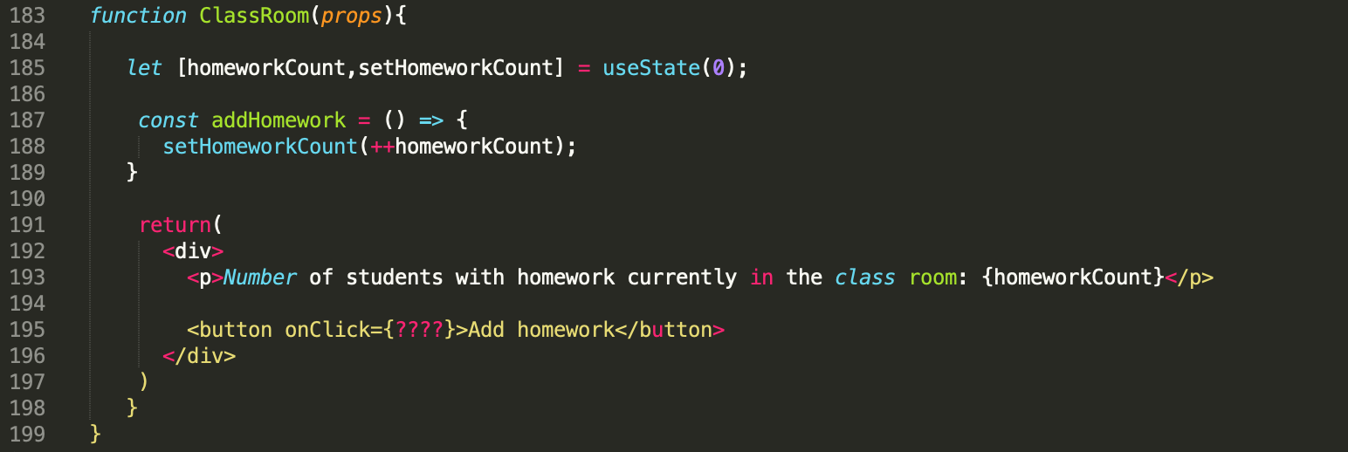Figure 1*

*In the code above the useState hook is used to set the state of a variable inside the component.*

1. Read the code and understand what is happening. How do you ensure the “addHomework” function is triggered when the button is clicked?

Answer: I need to call the addHomework() , on onClick button event.

<button onClick={addHomework}>Add homework</button>

1. When a user clicks on the “Add student” button update the state (homeworkCount) to include the total amount of homeworks of only the students who are present. Using the data provided below:

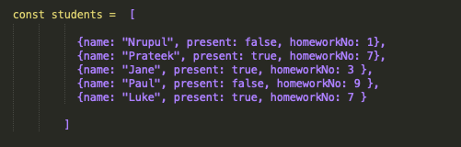

*Figure 2*

1. **Update the “addHomework” function and write a *pseudocode (or provide a description)*  of how your function would look.**

Answer:

const addHomework = () => {

let totalHomeworkPresentStudents = 0;

for (let i = 0; i < students.length; i++) {

// Check if the student is present

if (students[i].present) {

totalHomeworkPresentStudents += students[i].homeworkNo;

}

}

setHomeworkCount(totalHomeworkPresentStudents);

}

1. How will you update the state with the result of your function on button click?

Answer:

By calling the addHomework() on the onClick event of the button

**Part 2 (7 marks):**

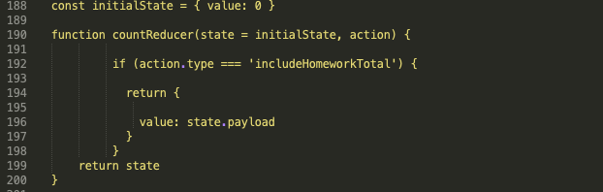

*Figure 3 (Reducer)*

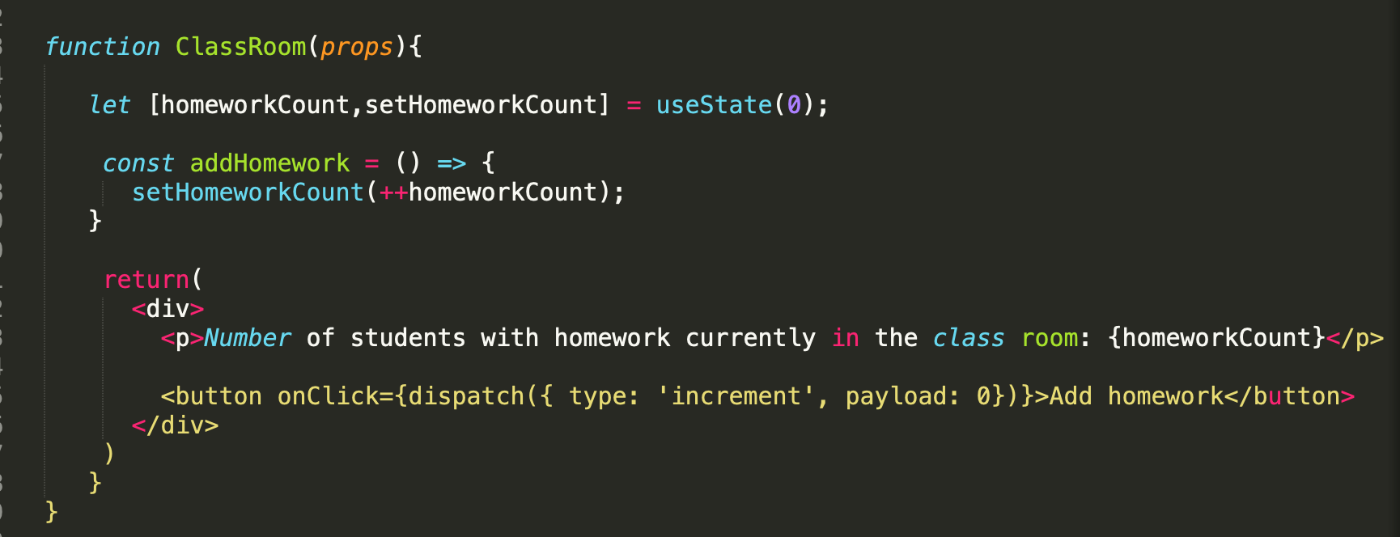

*Figure 4*

As you can see in the *ClassRoom* function the button onclick has been changed , the state is now being updated with the dispatch function on button click. Our *countReducer* uses the payload that is passed from the dispatch function and sets our state object to the payload.

1. At the moment on the classroom function our payload is set to 0. How do we ensure that our payload contains the result returned from the newly updated *addHomework* function? (The result should depend on your answer from part 1.2). What changes need to be made to our current code? *[Remember we want to dispatch this action when the user clicks on the button]*

*Answer:*

function ClassRoom(props) {

let [homeworkCount, setHomeworkCount] = useState(0);

const addHomework = () => {

const newHomeworkCount = homeworkCount + 1;

setHomeworkCount(newHomewrokCount);

returnnewHomeWorkCount;

};

return (

<div>

<p>Number of students with homework currently in the classroom: {homeworkCount}</p>

{/* Step 2: Dispatch the action with the payload from addHomework */}

<button onClick={() => dispatch({ type: 'includeHomeworkTotal', payload: addHomework() })}>

Add homework

</button>

</div>

);

}

1. According to the current countReducer function code, when I click on the “Add Homework” button, the state value would always be 17. Why is this happening? What changes can be made to our reducer code to ensure that the state value increases according to the latest payload.

|  |  |
| --- | --- |
| **Algorithms 1 (Coding)** | **20 (1 question)** |

Write an algorithm that returns true if the given string is a pangram. Otherwise, return false. Only lowercase alphabets are to be taken into consideration ( e.g. *AbC === abc*)

*Note: A pangram is a sentence containing every letter in the English Alphabet.*

If the input string contains only numbers value then return an error with the correct error message.

For example, some sample input and outputs would be:

|  |  |  |  |
| --- | --- | --- | --- |
|  | **String** | **Result** | **Explanation** |
| **Sample Input 1** | the quick brown fox jumps over the lazy dog | True | Contains all the characters from ‘a’ to ‘z’] |
| **Sample Input 2** | when zombies arrive, quickly fax Judge Pat | True | Contains all the characters from ‘a’ to ‘z’] |
| **Sample Input 3** | we will not allow you to bring your pet armadillo along. | False | Does not contains all the characters from ‘a’ to ‘z’] |
| **Sample Input 4** | 12356 | It must be a string | Only strings should be passed in. |

*In your answer, please discuss your solution - what is its Big O Time & Space complexity? Why have you chosen this approach? Could there be a more efficient way (and if so, how)?*

*If you are short on time, you can also submit pseudocode or simply describe what solution you’d write in code (just describe what you have in your mind) - this cannot attain full marks, but it is still a perfectly acceptable answer and can get partial marks.*

*In essence, just submit what you have even if you don’t know the answer!*

*Answerfunction isPangram(str) {*

*str = str.toLowerCase();*

*let alphabets = new Set("abcdefghijklmnopqrstuvwxyz");*

*for (let char of str) {*

*// Delete the character from the set if it exists*

*alphabets.delete(char);*

*// If the set is empty, all letters have been found*

*if (alphabets.size === 0) {*

*return true;*

*}*

*}*

*return false;*

*}*

*// Test cases*

*console.log(isPangram("The quick brown fox jumps over the lazy dog")); // should be true*

*console.log(isPangram("Hello, World!")); // should be false*

*console.log(isPangram("abcdefghijklmnopqrstuvwxyz")); // should be true*

|  |  |
| --- | --- |
| **Algorithms 2 (Coding)** | **25 (1 question)** |

Write a function that takes in two integers. Your function should return the integer that is first to become an odd integer by a smaller number of divisions by 4. If both numbers become an odd integer at the same time after the same number of operations then return 0.

|  |  |  |  |
| --- | --- | --- | --- |
|  | **Input** | **Output** | **Why?** |
| **Sample Input 1** | 20, 16 | 20 | Step 1: 20/4 = 5, 16/4 = 4  *20 is the first number to be converted to an odd integer.* |
| **Sample Input 2** | 36, 60 | 0 | Step 1: 36/4 = 9, 60/4 = 15  *Both numbers are converted to an odd integer at the same time.* |
| **Sample Input 3** | 32, 48 | 48 | Step 1: 32/4 = 8, 48/4 = 12  Step 2: 8/4 = 2, 12/4 = 3  *48 is first converted to an odd integer.* |

*If you are short on time, you can also submit pseudocode or simply describe what solution you’d write in code (just describe what you have in your mind) - this cannot attain full marks, but it is still a perfectly acceptable answer and can get partial marks.*

*In essence, just submit what you have even if you don’t know the answer!*

*Solution-function checkOdd(a,b){*

*let newA= a/4;*

*let newB= b/4;*

*// check if both intergeers are converted to an odd integer*

*if (newA%2 != 0 && newB%2!=0){*

*console.log("Both numbers are converted to an odd integer at the same time")*

*}*

*else*

*if(newA%2!=0)*

*{*

*console.log("integer"+ a +"is the first number to be converted to an odd integer")*

*}*

*else if(newB%2!=0){*

*console.log("integer"+ b+ "is the first number to be converted to an odd integer")*

*}*

*else{*

*console.log("Neither of the number to be converted to an odd integer")*

*}*

*}*

*//Test Cases*

*checkOdd(20,16)// should be "20" is the first number to be converted to an odd integer*

*checkOdd(36,60)//should be both numbers to be converted to an odd integer*

*checkOdd(32,48)// should be integer "48" to be converted to an odd*